TITLE OF The CONTRIBUTION
first name last name
AFFILIATION
name@name.EDU
(FIRST NAME LAST NAME
AFFILIATION
name@name.EDU

abstract
This is the publication template used in the 8th biannual Nordic Design Research Society (Nordes) Conference, NORDES 2019. It describes the formatting requirements for all contributions to the conference. Submissions to the conference must use this format (Poster submissions are the only exception to this, refer to the Poster Submission Category on the conference website. The easiest way to prepare your contribution is simply to use this document and replace the content with your own.
Every submission should begin with an abstract that fits the first column on the first page, like here. Proper length for the abstract is between 100-150 words. The abstract should be a concise statement of the argument, why it is important, your approach or idea, conclusions and contributions of the work to the field of design research.

Introduction
When creating your submission, you can use a standard word processing application and simply replace the content here with your own. This template contains special typeface styles (e.g. ‘NORDES Title’, ‘Contact info’, ‘Heading 1’, ‘Heading 2’, ‘Normal’, etc.), which you can use in order to format your own text properly and easily.
The paper title, author's names, affiliations, and email addresses run across the full width at the top of the first page, an example of a paper with two authors is given here. If affiliation or emails do not fit on one line, they can occupy multiple lines, as shown above, where a carriage return instead of a comma separates the institutional affiliation from the email.
Do not include other page numbers, headers or footers in your paper submission. Leave these as they appear on this template.

THE LENGTH OF THE CONTRIBUTION
This template applies to five Submission Categories to the conference: Full papers, Exploratory Papers, Posters, Workshops and Doctoral Consortium. Descriptions of these categories and appropriate content are found on the conference website: https://nordes2019.aalto.fi.

Full papers
Full Papers should be between 5000-6000 words including abstract and references. Make sure to limit the file size to 5MB or less.

Exploratory papers (short)
Short research papers should stay within 3000 words, including abstract and references. Make sure to limit the file size to 5MB or less.

Posters
Poster proposals should be submitted as an extended abstract, including a visual suggestion for the proposed poster. Abstracts should stay within 1500 words. Make sure to limit the file size to 5MB or less.

Workshops
Workshop proposals should be submitted in this template. Maximum length of a workshop proposal is 3000 words, including abstract and references, they may also be shorter. Make sure to limit the file size to 5MB or less.

Doctoral Consortium
The submissions for the Doctoral Consortium (DC) should be between 1500-3000 words. A position paper outlines the research plan or research-in-progress and the need for it to be addressed in the DC.

CONFERENCE topic AND SUB THEMES
All submissions will be assessed based on quality and relevance. Please ensure that you address the conference theme “WHO CARES?” directly, and we recommend that you refer to the themes stated on the conference website.

AnonymIZE FULL and exploratory paper submissions
Full and exploratory papers will be subject to double-blind peer review and accepted papers in these categories will be entered into the searchable online NORDES digital archive. Full and exploratory papers should be anonymized before submission – author(s) are required to make a good-faith effort to preserve the anonymity of their submission, while at the same time allowing reviewers to fully grasp the content and context.
Minimally, authors of full and exploratory paper submissions should take the following steps when preparing your submission:
- Remove the names and affiliations of authors from the title page.
- Remove acknowledgment of identifying names and funding sources.
- Use care in naming your files. Source file names are often embedded in the final output as readily accessible comments.
- Use care in referring to related work, particularly your own. Do not omit references to provide anonymity, as this leaves the reviewer unable to grasp the context. Instead, reference your past work in the third person, just as you would any other piece of related work by another author.
For accepted full and exploratory papers, authors should reintroduce all anonymised names and references.

COLOUR, FIGURES, AND VIDEO
Colour figures such as diagrams and images are encouraged – this is a design conference! When using colour in diagrams, please, remember that many people print papers with a black-and-white printer. You can ensure that your paper works on black and white by doing a test-print.
Figure 1: Include captions for images.
Place figures close to the sections referring to them. Refer to all of the figures in text (see Figure 1). Figures may extend across one or both columns and should be labelled with captions underneath.
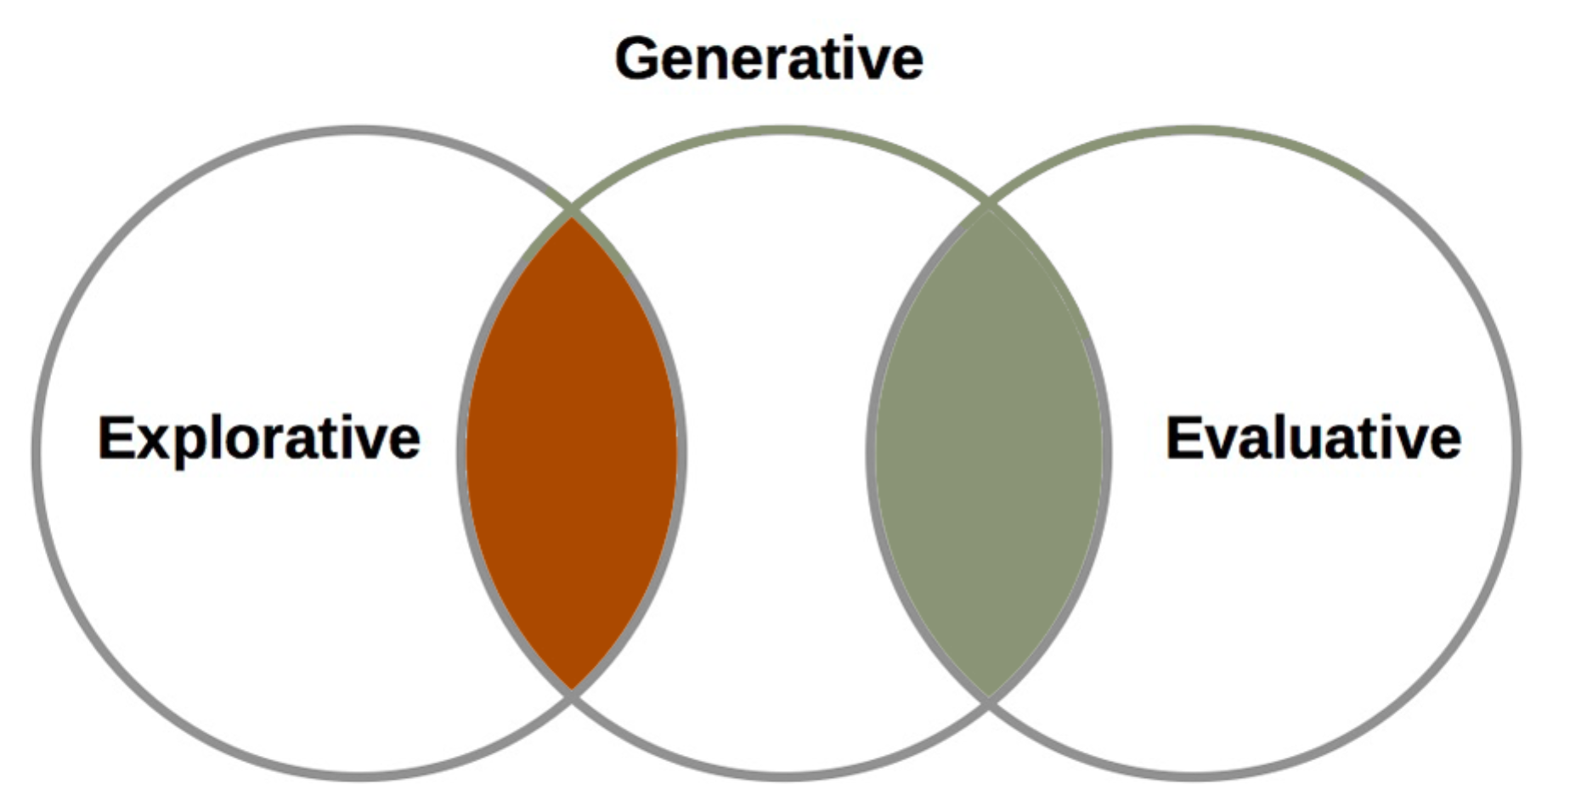
Figure 2: Example of a graph
Videos can be linked to the document. One way to link is to use a screenshot from the video and add a link in the caption. We suggest using long-lasting sites for storing the video files, such as Vimeo.

Tables
Tables should be used where appropriate for the display of tabular information. Tables should be labelled with a caption in ‘Caption’ style above the table. Tables can be referred to in the following way (see Table 1). Tables should use the ‘Table text’ style for internal text. Please use bold text for table headings.
Table 1: NORDES 2019 conference key dates.
Day | Key dates
15 January 2019 | Deadline for submitting full and exploratory papers and posters (this is a hard deadline, there will be no extensions)
12 February 2019 | Deadline for submitting workshop proposals and DC position papers (this is a hard deadline, there will be no extensions)
10 March 2019 | Notification to the authors
5 April 2019 | Early bird registration deadline  Deadline for submitting final versions of papers
2-4 June 2019 | Conference

FORMATTING GUIDELINES
The paper should be formatted for A4 page size (21 x 29.7 cm) with margins of 2 cm on all sides. Columns should be of equal width, with a space between them measuring 0.8 cm.
Authors should carefully read, edit and language-check their submission and also double-check all references.
Spelling and punctuation may follow any consistent variety of English (e.g., British, Canadian or American). Hyphenation is at your own discretion, but we suggest that only native English speakers with a Masters degree or more in English hyphenate – for the rest of us, hyphenating that language is time-consuming and prone to errors. We recommend writing in a straightforward style avoiding complex, colloquial, and gendered language, as well as explaining acronyms used and technical terms the first time they appear in the paper. Formal, specialist and technical language should be used with precision, definitions and citations.
Please, use the full (extended) alphabetic character sets (for example, the letters ø, é, å, ç, â, ö, etc. in names of people, institutions and places as appropriate to the origin of the word). These characters are already included in the font used in this template and in most common typefaces.

Subsections
Paragraph and line spacing are applied automatically if you use the Microsoft Word styles to format your text.

font Instructions
The font used throughout the paper is Times New Roman Normal mixed case, unless specified otherwise.

Normal
- To be used for the main text throughout the paper.
- Size 10pt / Line spacing 12pt / 6pt after.

Caption
- To be used for captions beneath figures and transcripts.
- Size 9pt / Line spacing 9.6pt / 10pt after.

Table text
- To be used for internal table text
- Size 9pt.
- (Bold for table headings).

NORDES Title
- To be used for main title of the paper.
- Size 27pt / Line spacing 31pt.
- CAPITAL CASE.

Contact info
- To be used for author names, affiliations and email addresses.
- Size 10pt / line spacing 12pt.
- CAPITAL CASE.

Heading 1
- To be used for level 1 headings in the paper.
- Size 11pt / Line spacing 13.2pt / 11pt before / 2pt after.
- CAPITAL CASE.

Heading 2
- To be used for level 2 headings in the paper.
- Size 9pt/ Line spacing 12pt / 9pt before.
- CAPITAL CASE.

NORDES Abstract Header
- To be used for the heading of the abstract.
- Size 11pt / Line spacing 12pt / 11pt before / 8pt after.
- CAPITAL CASE.

NORDES Abstract Text
- To be used for the text of the abstract.
- Size 11pt / Line spacing 1.5 lines / 6pt after.

NORDES References
- To be used for references.
- Size 10pt / Line spacing 12pt / 6pt after
- Hanging paragraph indentation of 0.7 cm.

REFERENCing
References must be used consistently following the Harvard Style (Library.leeds.ac.uk, 2018). References in text are noted with author and year in brackets. Examples of using references in running text:
“... Ylirisku and Arvola (2018) argue that design traditions are based on foundationally different categories of goodness.”
“Design traditions are based on foundationally different categories of goodness (Ylirisku & Arvola, 2018)”
At the end of the document is a list of References is to be provided in alphabetical order (not using numbers as is done in e.g. Computer Science). References must be fully checked and contain FULL information, i.e. page numbers, volume and number of journals, etc.

References
Library.leeds.ac.uk. (2018). Leeds Harvard referencing examples | Study and research support | Library | University of Leeds. [online] Available at: https://library.leeds.ac.uk/referencing-examples/9/leeds-harvard [Accessed 18 Nov. 2018].
Ylirisku, S. & Arvola, M. (2018) Varieties of Goodness in Design. In: P. Vermaas & S. Vial eds. Philosophy of Design: An Exploration. Design Research Foundations. Springer, pp.51–70.

Columns on the final pAge should be of equal length

